# Recent changes in clinical trials across the globe

# Feb 02nd 2022 Observations

# Table of contents

1. Introduction
2. Top 10 Trial Conditions for 2 years
3. Distribution of Source Register across Study types for 2 years
4. Distribution of Source Register across Trial Conditions for 2 years
5. Flow of Trials across Sources to Study types to Conditions for 2 years

## Introduction

With reference to WHO’s ICTRP dataset for the last 2 years and performed 2 times in the time range of two weeks.

## Top 10 Trial Conditions for 2 years

**Analysis Performed on 1st Feb, 2022**

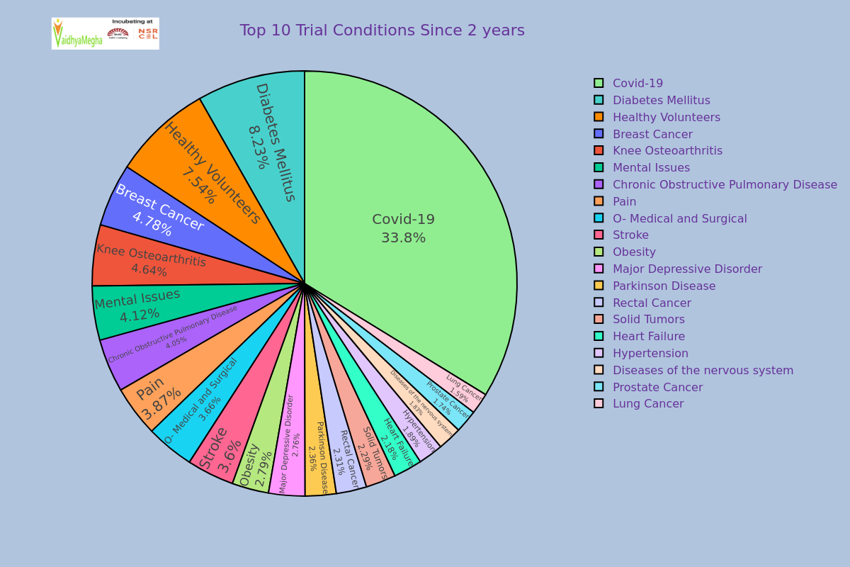

Analysis Performed on 1st Feb, 2022

**Analysis Performed on 25th Jan, 2022**

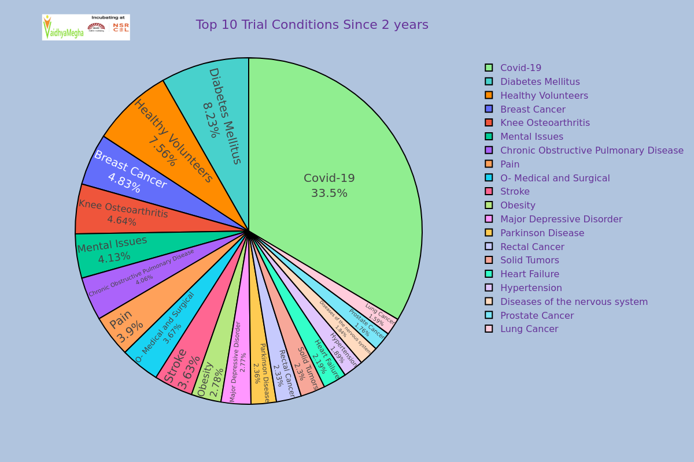

Analysis Performed on 25th Jan, 2022

By seeing above two charts of analysis which were performed on 1st Feb 2022 and 25th Jan 2022 , we can observe that the changes of percentages of some trials in two weeks approximately.

|  |  |  |  |  |
| --- | --- | --- | --- | --- |
| S. No. | Trial Condition | % Of first analysis | % Of second analysis | Remarks |
| 1 | Covid -19 | 33.8 | 33.5 | Increased by 0.3% |
| 2 | Diabetes Mellitus | 8.23 | 8.23 | No Change |
| 3 | Healthy Volunteers | 7.54 | 7.56 | Increased by 0.02% |
| 4 | Breast Cancer | 4.78 | 4.83 | Decreased by 0.05% |
| 5 | Knee Osteoarthritis | 4.64 | 4.64 | No Change |
| 6 | Mental Issues | 4.12 | 4.13 | Decreased by 0.01% |
| 7 | Chronic Obstructive Pulmonary Diseases | 4.05 | 4.06 | Decreased by 0.01% |
| 8 | Pain | 3.87 | 3.90 | Decreased by 0.03% |
| 9 | O- Medical and Surgical | 3.66 | 3.67 | Decreased by 0.01% |
| 10 | Stroke | 3.60 | 3.63 | Decreased by 0.03% |

From the above there is a 0.3% increment in Covid-19 and 0.02% increment in Healthy Volunteers.

## Distribution of Source Register across Study types for 2 years

**Analysis performed on 1st Feb, 2022**

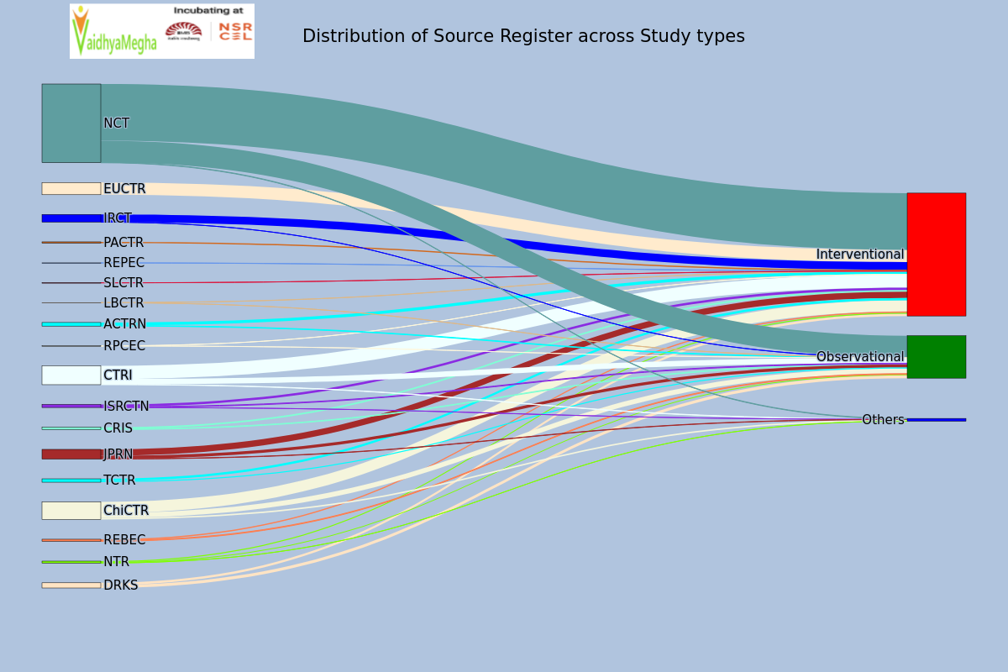

Sankey-1 : Source to Study type

**Analysis performed on 25th Jan, 2022** 

|  |  |  |  |  |
| --- | --- | --- | --- | --- |
| S.No | Source Register | Interventional | Observational | Others |
| 0 | ACTRN | 42 | 13 |  |
| 1 | CRIS | -10 | -5 |  |
| 2 | CTRI | -91 | -31 | -2 |
| 3 | ChiCTR | -61 | -19 | -13 |
| 4 | DRKS | -19 | -19 |  |
| 5 | EUCTR | -66 |  |  |
| 6 | IRCT | -68 | 0 |  |
| 7 | ISRCTN | -12 | -4 | 0 |
| 8 | JPRN | -39 | -11 | 0 |
| 9 | LBCTR | 0 | 0 |  |
| 10 | NCT | -467 | -144 | -3 |
| 11 | NTR | -8 | -7 | 0 |
| 12 | PACTR | -10 |  |  |
| 13 | REBEC | -19 | -1 |  |
| 14 | REPEC | -1 |  |  |
| 15 | RPCEC | 0 | 0 |  |
| 16 | SLCTR | -1 |  |  |
| 17 | TCTR | -16 | -3 |  |

The above table represents the changes in clinical trials registrations in two weeks approximately.

# Distribution of Source Register across Trial Conditions for 2 years

**Analysis performed on 1st Feb, 2022** 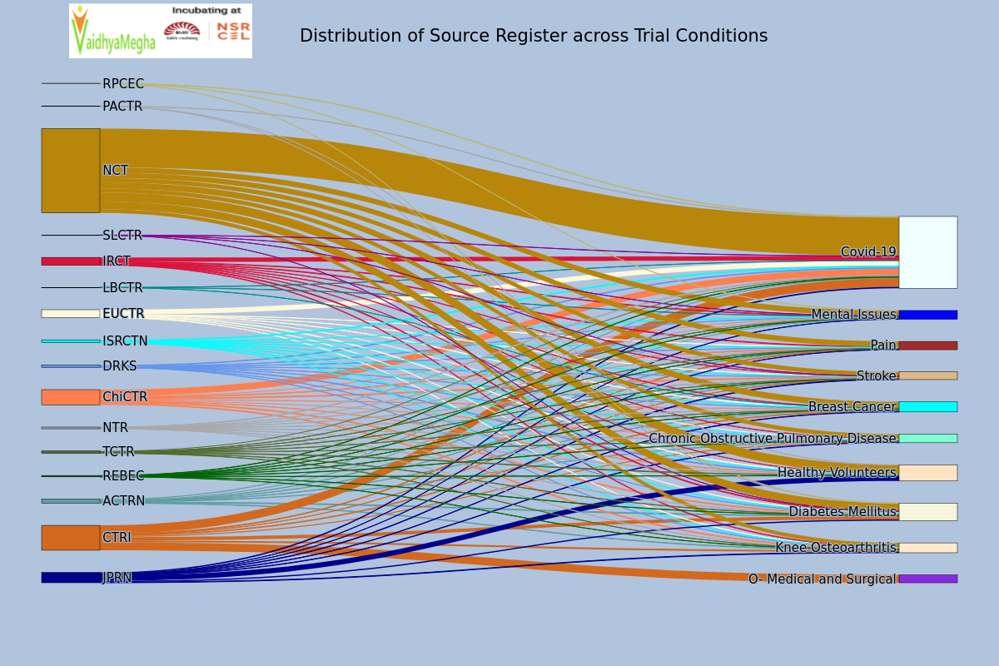

**Analysis performed on 25th Jan, 2022** 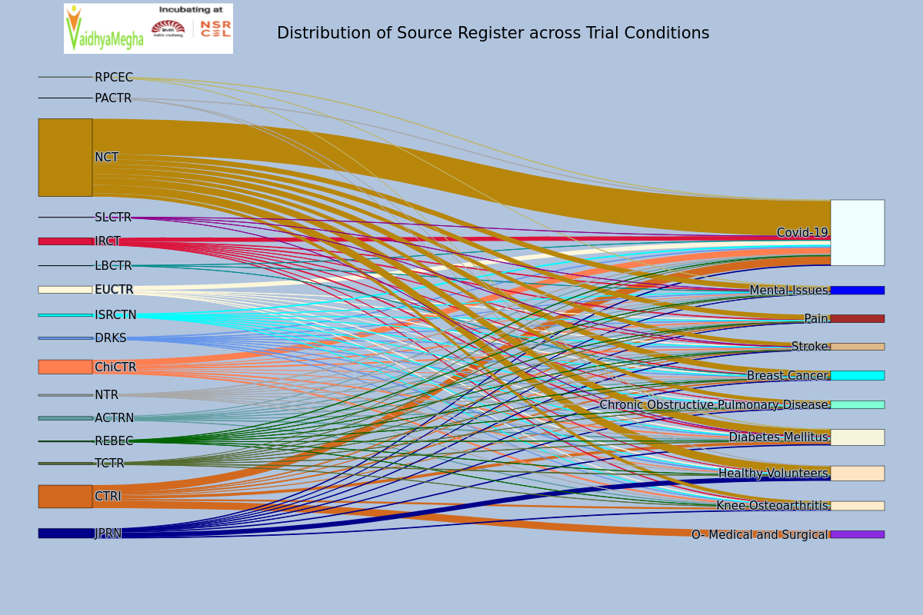

|  |  |  |  |  |  |  |  |  |  |  |
| --- | --- | --- | --- | --- | --- | --- | --- | --- | --- | --- |
| Source Register | Breast Cancer | Chronic Obstructive Pulmonary Disease | Covid-19 | Diabetes Mellitus | Healthy Volunteers | Knee Osteoarthritis | Mental Issues | O- Medical and Surgical | Pain | Stroke |
| ACTRN | -1 | 1 | 3 | 3 |  | 2 | 1 |  | 2 | 1 |
| CTRI | -1 | -2 | 0 | -3 |  | -1 |  | -7 | -1 | 0 |
| ChiCTR | -2 | 0 | -2 | -1. | 0 | -1 | 0 |  | 0 | -2 |
| DRKS | 0 | 0 | 0 | 0 | -1 | 0 | 0 |  | 0 | 0 |
| EUCTR | -2 | 1 | 1 | -2 | 0 | 0 |  |  | 0 | 0 |
| IRCT | -1 | -1 | 0 | 0 | 0 | -1 | -2 |  | -3 | -1 |
| ISRCTN | 0 | -1 | 1 | 0 | 0 | -2 | 0 |  | -1 | 0 |
| JPRN | -1 | 0 | 0 | -2 | -6 | 0 | -1 |  | 0 | 0 |
| LBCTR | 0 |  | 0 |  |  |  | 0 |  |  |  |
| NCT | -11 | -8 | 11 | -8 | -8 | -4 | -6 |  | -12 | -9 |
| NTR | -1 | 0 | 0 | 0 | 0 | 0 | 0 |  | 0 | -1 |
| PACTR |  |  | 0 | 0 | 0 |  |  |  |  |  |
| REBEC | -1 | 0 | 0 | 0 | 0 | 0 | 0 |  | 0 | 0 |
| RPCEC |  |  | 0 | 0 |  |  | 0 |  |  |  |
| SLCTR |  |  | 0 | 0 |  |  | 0 |  |  | 0 |
| TCTR | 0 | 0 | 0 | 0 | -2 | 0 | 0 |  | 0 | 0 |

The above table represents the increment in clinical trials registrations in two weeks approximately. From the above table, clinical trials on Covid-19 were registered from almost every Source. Diabetes Mellitus , Psychological problems and Stroke are also health issues in almost every nation.

# Flow of Trials across Sources to Study types to Conditions for 2 years

**Analysis performed on 1st Feb, 2022** 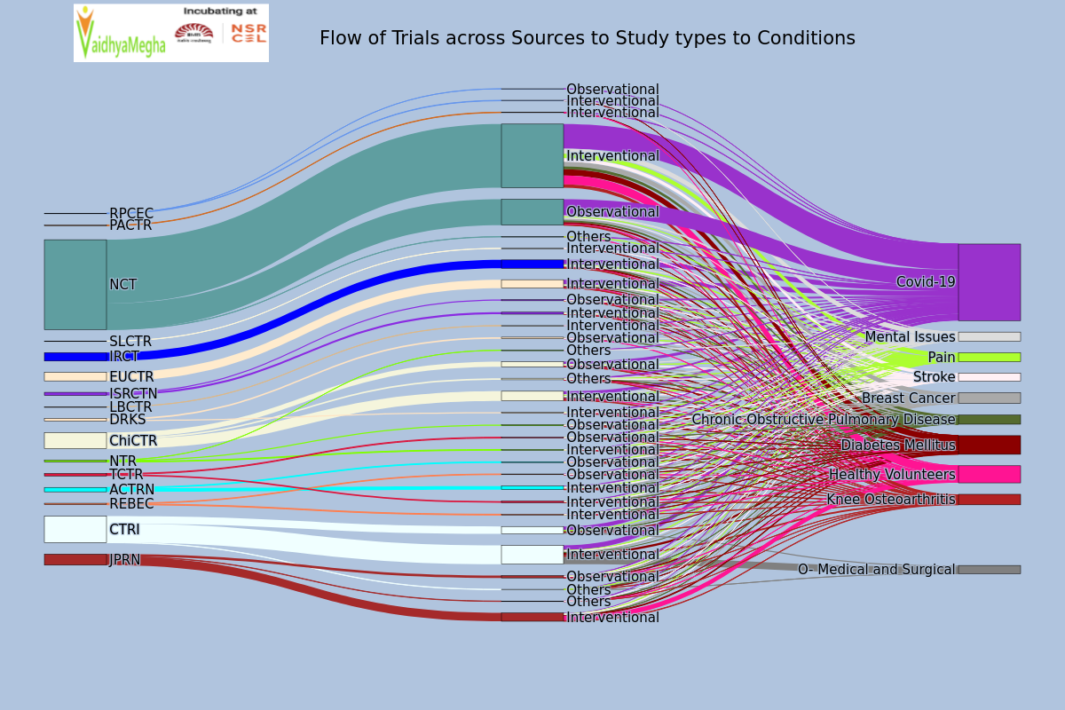

**Analysis performed on 25th Jan, 2022** 